**REFERENTS**

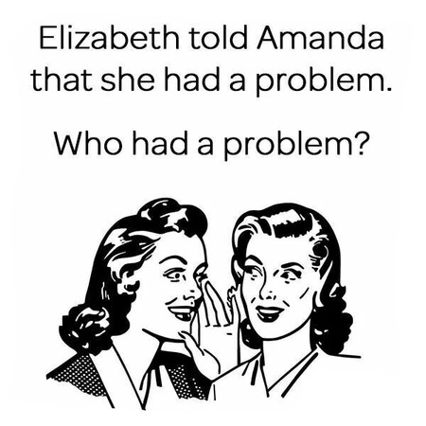

Referents are those words that replace other words. Transitional markers, as they are also known, link ideas together so that text is smoother to read. When personal pronouns such as **it, they, he, she, we,** objectpronouns **them, him, her, us,** reflexivepronouns **themselves, himself, herself, ourselves,** demonstrative pronouns **this, that, these and** **those,** adjectivespronouns **its, their, his, her, our,** relative pronouns **which, who, whose, where, when, that,** and such as are used as transitional markers, they refer to a word, or words, mentioned earlier in the sentence or paragraph. Their function is to take your thoughts back to something that has already been mentioned. Thus they serve as synonyms or substitutes. Other words which are often used to refer backwards are **the former, the latter, the first, second, etc., the last.**