**SCANNING**

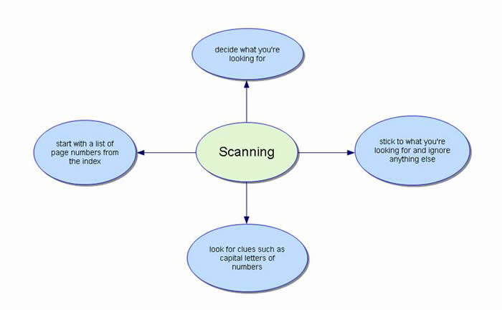

Scanning is a reading strategy that covers a great deal of material in order to locate the specific fact or piece of information. It's very useful for finding a specific name, date, statistic or fact without reading the entire text. When scanning, look for the author's use of organizers such as numbers, letters, steps, or the words, first, second, or next. Look for words that are bold faced, italics, or in a different font size, style, or color.

**Steps in scanning a text:**

- keep in mind what you are looking for.

- Anticipate in what form the information is likely to appear (numbers, nouns, verbs, etc.).

- Analyze the organization of the content before starting to scan.