1. **READ AND ANSWER THE QUESTIONS**

Computer software is a general term that has described computer programs. Related terms such as software programs, applications, scripts, and instruction have set under the category of computer software. It has been difficult to describe because it is "virtual," or not physical like computer hardware. Instead, software consists of lines of code written by computer programmers that have been compiled into a computer program. Software programs are stored as binary data that is copied to a computer's hard drive, when it is installed. Software has consisted of binary data, CD-ROMs, DVDs, and other types of media that are used to distribute software. Therefore, when you have bought a software program, it often comes on a disc, which is a physical means of storing the software.

1. What is the title of the reading?

___________________________________________________________________________

1. What have a software or a program meant?

___________________________________________________________________________

1. Is it physical or virtual?

___________________________________________________________________________

1. How has the software been stored?

___________________________________________________________________________

1. How has the software been distributed? ___________________________________________________________________________
2. **LOOK AT THE IMAGE ABOVE AND WRITE ABOUT 5 PROGRAMS YOU IDENTIFY**

____________________________ _______________________ ______________________ ____________________________ ________________________

1. **UNDERLINE THE PRESENT PERFECT SENTENCES ON THE TEXT**
2. 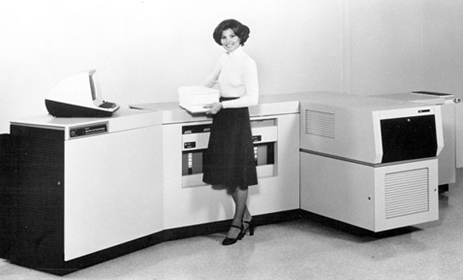**READ AND ANSWER THE QUESTIONS**

In 1938, Chester Carlson had invented a dry printing process called electrophotography commonly called a Xerox, the foundation technology for laser printers to come. Then in In 1953, Remington-Rand had developed the first high-speed printer, for use on Univac computer. After that, In 1971 Xerox Palo Alto Research Center had completed the original laser printer called EARS, Xerox Engineer, Gary Starkweather had adapted Xerox copier technology adding a laser beam to it to come up with the laser printer, next in 1976, Hewlett-Parkard's had invented the inkjet printer, but it took until 1988 for the inkjet to become a home consumer, it cost $1000, and in 1992, Hewlett-Packard had released the popular LaserJet 4, the first 600 by 600 dots per inch resolution laser printer.

1. What was the foundation for laser printers?

___________________________________________________________________________

1. Who developed the first high-speed printer?

___________________________________________________________________________

1. What was EARS?

___________________________________________________________________________

1. Who added a laser beam to a printer?

___________________________________________________________________________

1. What happened in 1992? ___________________________________________________________________________
2. **UNDERLINE THE PRESENT PERFECT SENTENCES ON THE TEXT**